241 Toll Road Extension: Digitalization and Watershed Analysis
  - By: Bennet Russell & Matthew Flaherty
  - 4/29/2016

Abstract
The aim of this study was to examine the spatial proximity of the extension of State Route 241 to local waterways. Water quality concerns have been a reason for concern for the project and is the reason for the TCA’s inability to receive the needed build permits. A spatial analysis was done on the proximity of the proposed extension to San Mateo Creek. Little of the road come in direct contact with the stream and little of the road is within 200 meters of the stream. Further study must be done to determine the environmental significance of the given proximities and their effect on sediment flow.

Introduction
The Foothill/Eastern Transportation Agency (TCA) has proposed an extension of State Route 241 from its current end at Oso Parkway to Interstate-5( I-5). The new extension would connect with the I-5 in north San Diego County by its border with Orange County. The project promises to alleviate traffic of southern Orange County and northern San Diego County by allowing traffic to bypasses a portion of the I-5. The proposed project is part of a larger plan to create more transportation pathways in order to meet the future increase in population of Orange County (US Census Bureau).
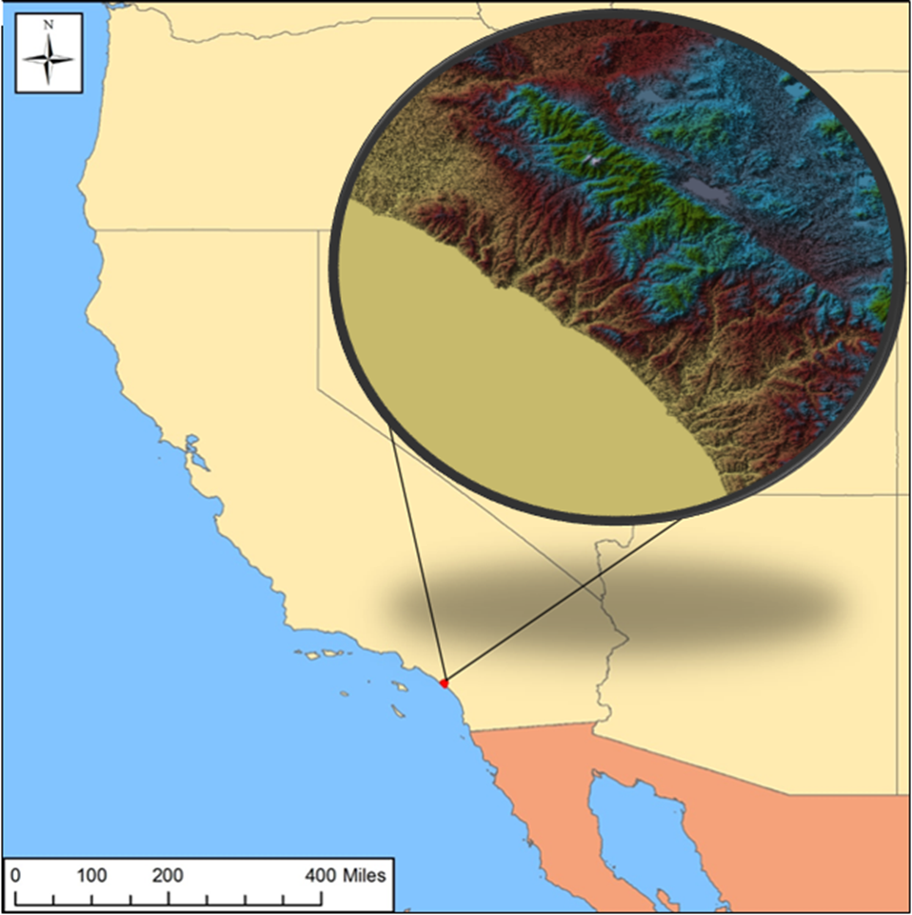igure 1. Shows the location of San Clemente in Southern California as a red dot where the toll road is being proposed to be put in. San Clemente is shown in more detail at the top right of the map.

The 241 extension has had a long history of controversy since its announcement in 2004. Opponents of the proposal have argued the environmental effects to the surrounding area, particularly to San Onofre State Beach, are of greater importance than the decrease in traffic.
San Onofre is home to one of surfing’s most coveted breaks, Trestles. It consistently provides long, fast rights that attract surfers from around the world. The break is characterized by its cobblestone bottom but is highly dependent on sediment loads from the nearby San Mateo Creek. The transported sand fills in between the cobblestone to create a world-class sandbar.
The 241 extension was denied the needed permits to continue to construction in 2013 and again in 2016 due to water quality concerns. Despite its inability to retain the needed permits and the overt public opposition to the project, TCA has not thrown the project out of consideration.
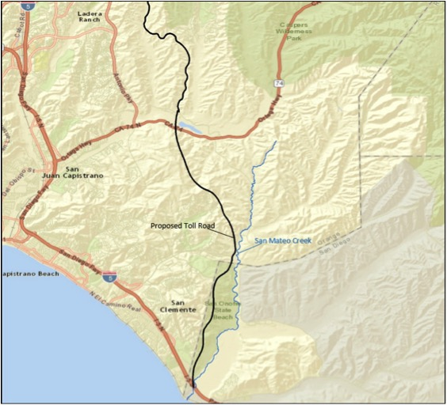

Figure 2 shows the entirety of the 241 toll road extension.
A strong public opposition to toll road extension has surfaced due to a successful political campaign headed by The Surfrider Foundation. Using the Save Trestles slogan, the non-profit has been able to gain a politically active, grass roots base. Knowledge of the project specifics (site location) is relatively unknown by the common public. In this report we look to examine the spatial proximity of the 241 extension to local waterways.

Methods
The route for the 241 extension was digitized in ArcMap from Esri, Inc. using the A7C-FEC-M route proposed in the addendum of the impact report prepared by the TCA (Transportation, South Orange County 2013). San Mateo Creek was also digitized using the base map provided by ArcMap. Buffers of 50, 100, 150, 200, and 300 meters around the San Mateo Creek shape file were created. Each buffer layer was intersected with the toll road layer. The length of road that intersected with each buffer was calculated using Calculate Geometry (Table 1).

Results
The toll road extension is predominately a concern for water quality at its middle to southern end where it comes in closer proximity to San Mateo Creek. Road lengths at specific distances is displayed in Table 1.

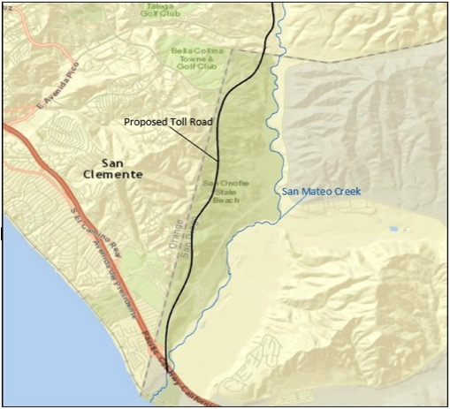
Figure 3 shows the area of most concern for water quality because of the toll road’s proximity to San Mateo Creek

Table 1 displays distances from San Mateo Creek and the length of road that can be found at the correlating distance.
Distance from Waterway (meters) | Length of Road (miles)
50 m | 0.03 mi
100 m | 0.35 mi
150 m | 0.63 mi
200 m | 0.91 mi
300 m | 1.62 mi

Conclusion
The results show little overlap between the 241 extension and San Mateo Creek; only occurring at the interchange with Interstate 5. This report does not attempt to prove or disprove the claim of environmental significance of the proximity of the road to the stream. Further study should be done on whether the given proximity is of environmental impact concern.

Bibliography

TRANSPORTATION, SOUTH ORANGE COUNTY. "TESORO EXTENSION PROJECT." (2013).

